Geometry Honors Name__________________________________

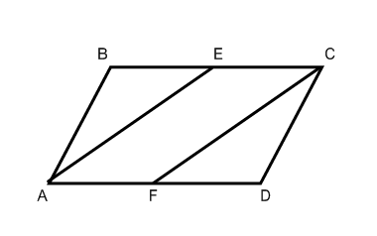5-1 and 5-2 Proofs

1. Given: ABCD is a parallelogram

E is the midpoint of 

F is the midpoint of 

Prove: 

|  |  |
| --- | --- |
|  |  |
|  |  |
|  |  |
|  |  |
|  |  |
|  |  |
|  |  |
|  |  |
|  |  |
|  |  |

2. Given: ABCD is a parallelogram, 

Prove: 

|  |  |
| --- | --- |
|  |  |
|  |  |
|  |  |
|  |  |
|  |  |

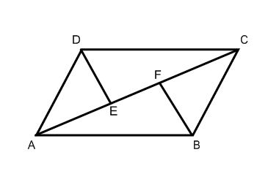3. Given: ABCD is a parallelogram,



Prove: 

|  |  |
| --- | --- |
|  |  |
|  |  |
|  |  |
|  |  |
|  |  |
|  |  |
|  |  |
|  |  |
|  |  |
|  |  |

4. Given: ABCD is a parallelogram



Prove: 

|  |  |
| --- | --- |
|  |  |
|  |  |
|  |  |
|  |  |
|  |  |
|  |  |
|  |  |
|  |  |
|  |  |
|  |  |

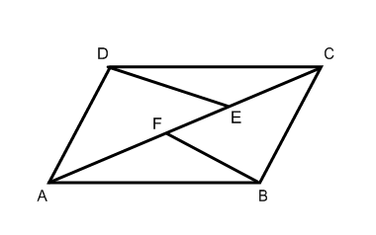5. Given:  is a diagonal in parallelogram ABCD



Prove: 

|  |  |
| --- | --- |
|  |  |
|  |  |
|  |  |
|  |  |
|  |  |
|  |  |
|  |  |
|  |  |
|  |  |
|  |  |
|  |  |
|  |  |
|  |  |

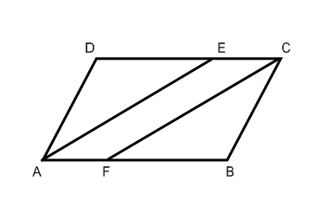6. Given: ABCD is a parallelogram



Prove: 

|  |  |
| --- | --- |
|  |  |
|  |  |
|  |  |
|  |  |
|  |  |
|  |  |
|  |  |
|  |  |
|  |  |
|  |  |
|  |  |
|  |  |